COVID 19: Writing Challenges for Friends of Chartres
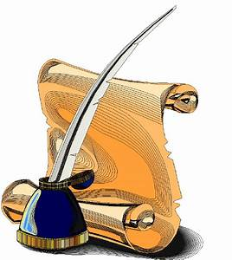

Did you know that Shakespeare wrote King Lear whilst quarantined during a plague epidemic?

During these difficult times you might like to get creative so we have come up with some story lines for you to play with…
You can literally take these in any direction you wish and your story can be any length from a Flash Fiction of 50 words to a substantial short story of up to 3000 words.
It could be a play script, a dialogue, a journal, a first-person narrative or written from the point of view of one person, or several.
You can take an idea each week, or you can pick out one or two that appeal to you.
This is not a competition; it is simply an idea to occupy you and keep your brains ticking over. However, we'd love you to share your efforts with us - so, when you are happy with what you have written - email to focmail1959@gmail.com
Here are our suggestions:
- A resident of Chartres in 1939 is working with the Resistance under Jean Moulin

- A resident of Chichester in 1475 helps to build the plague chapel on the Trundle…or a resident in the 1664 epidemic

- A resident of Chartres during the French Revolution

- A resident of Chichester during the English Civil War

- A group of Twinning members on their annual exchange, in either city

- A family gathering with delicious food (French or English)

- The Bishop/ Evêque’s housekeeper explores her master’s study

